Name: Ankur Prajapati StudentID: N01324892

Practice I-1:

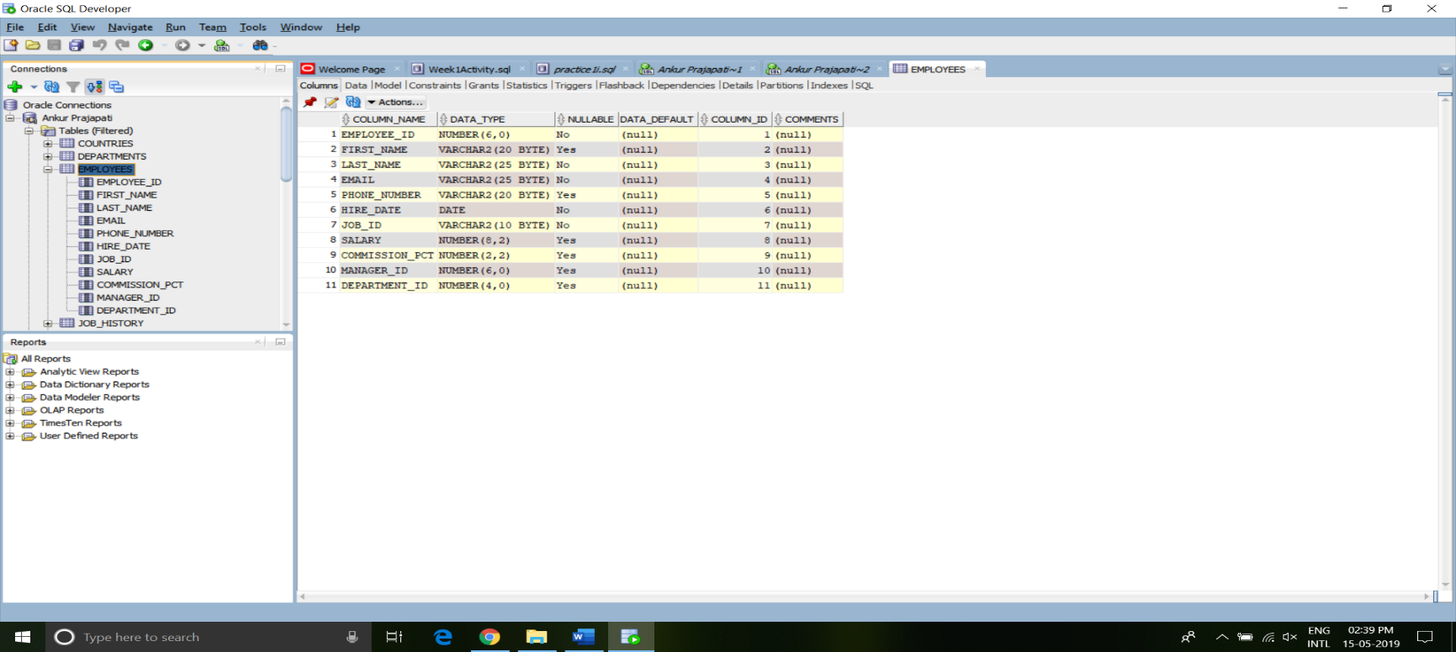4.

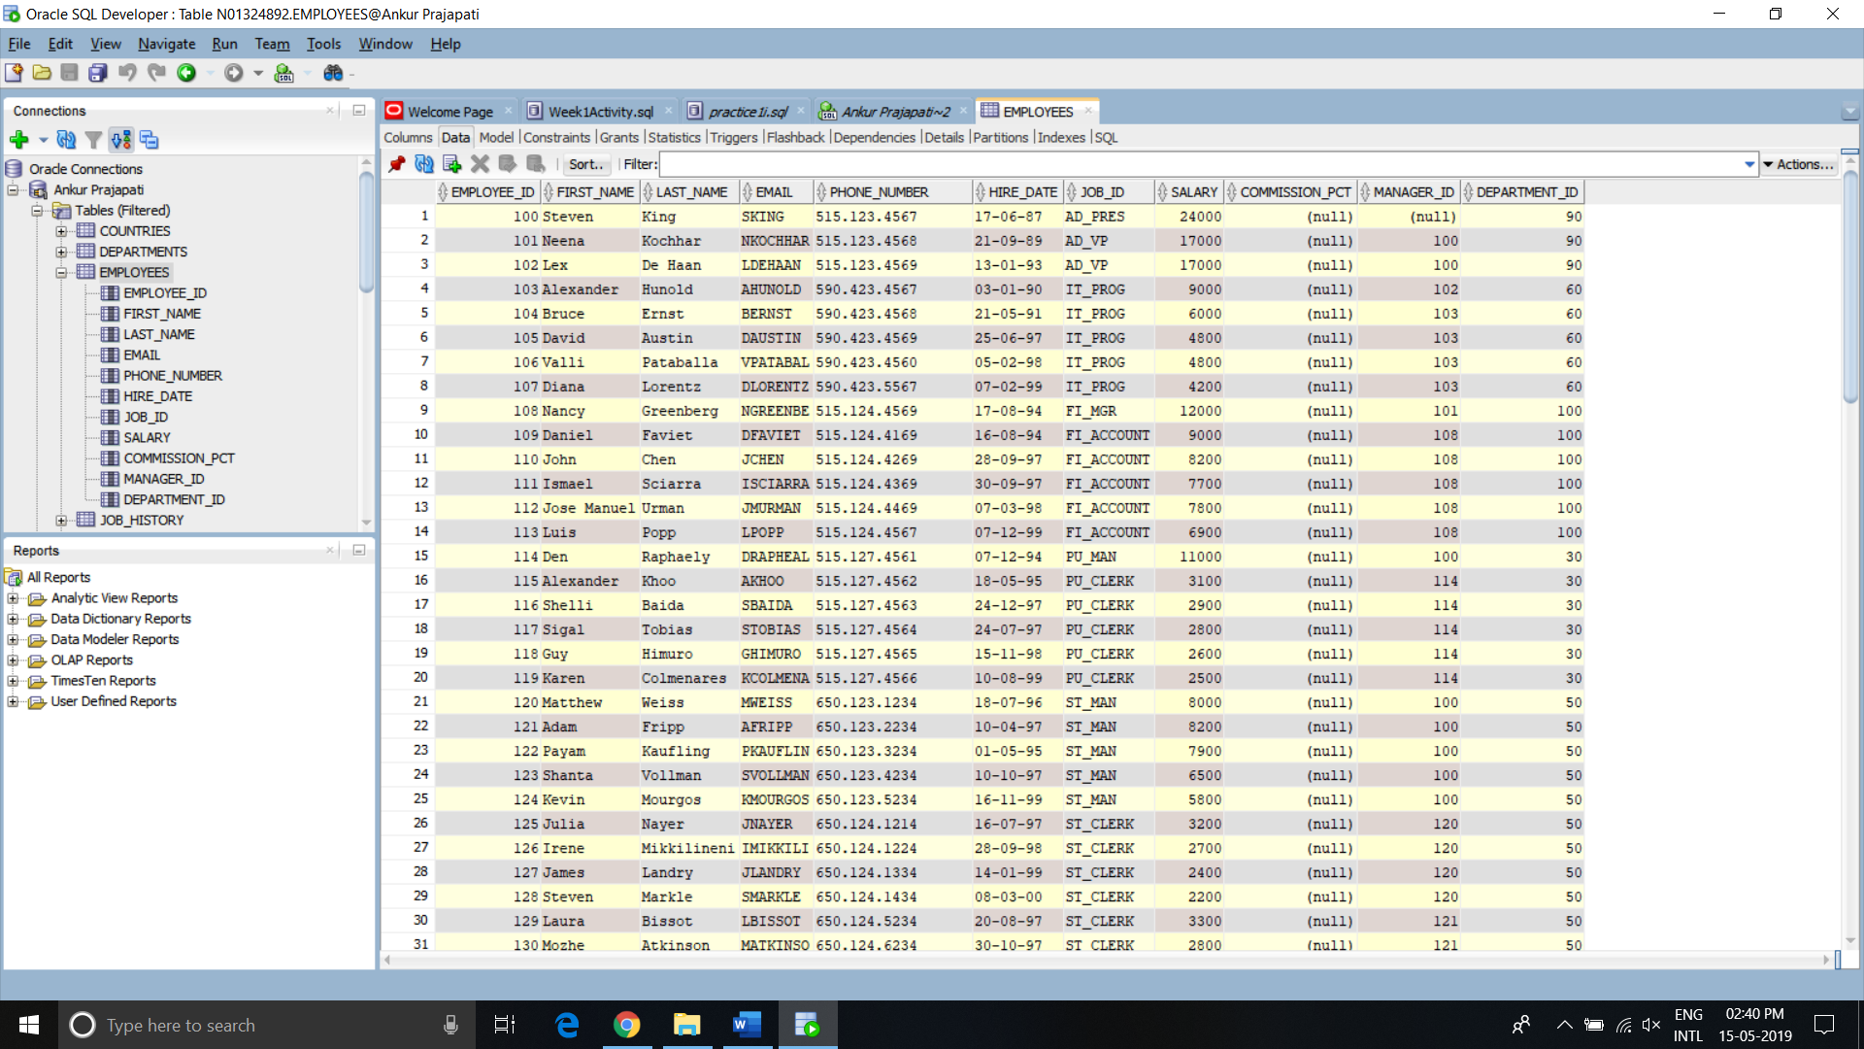5.

6. F9:

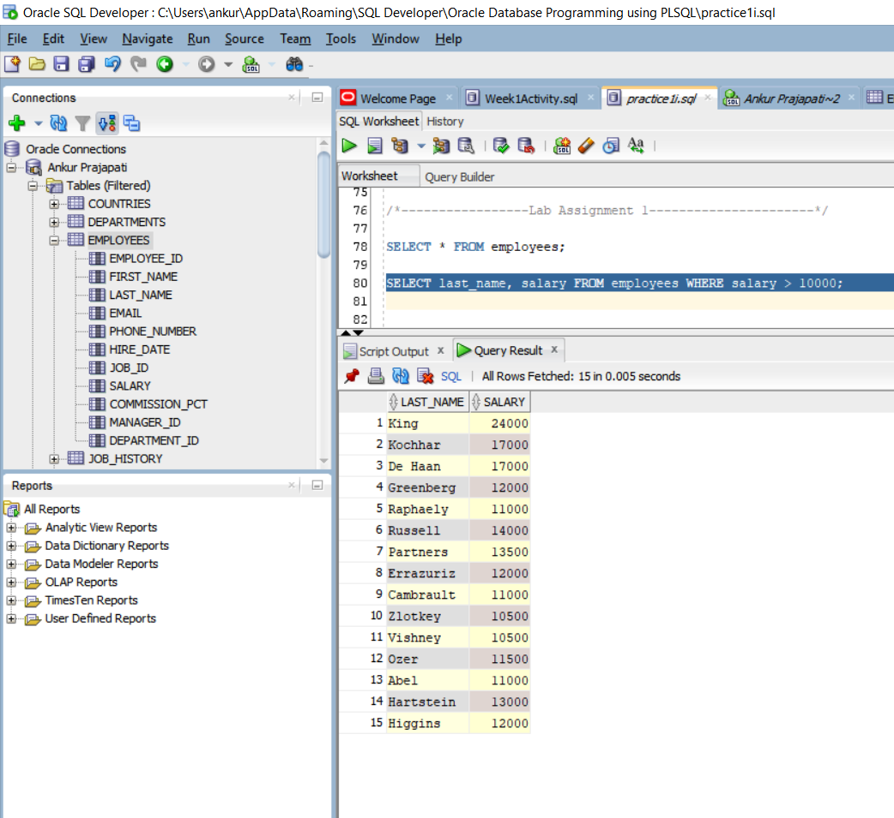

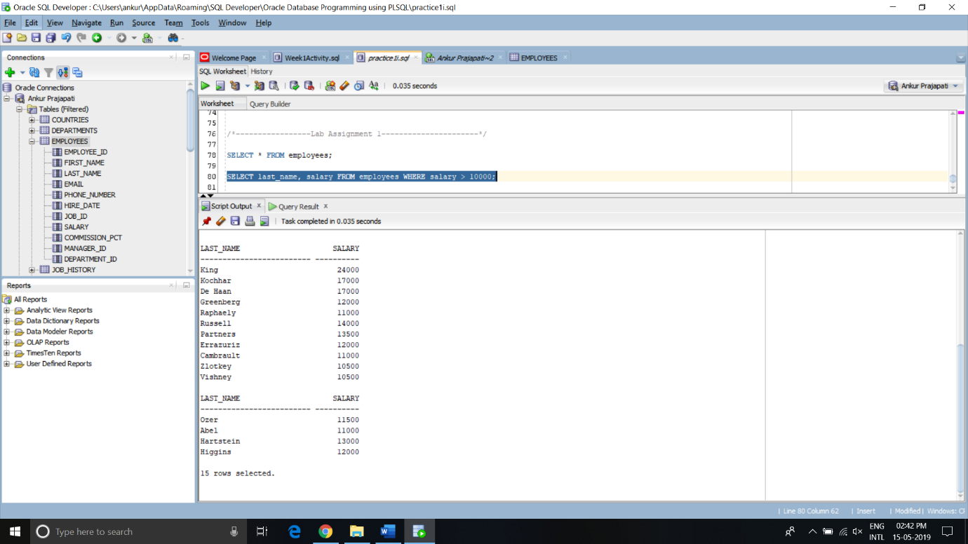F5:

Practice 1-4:

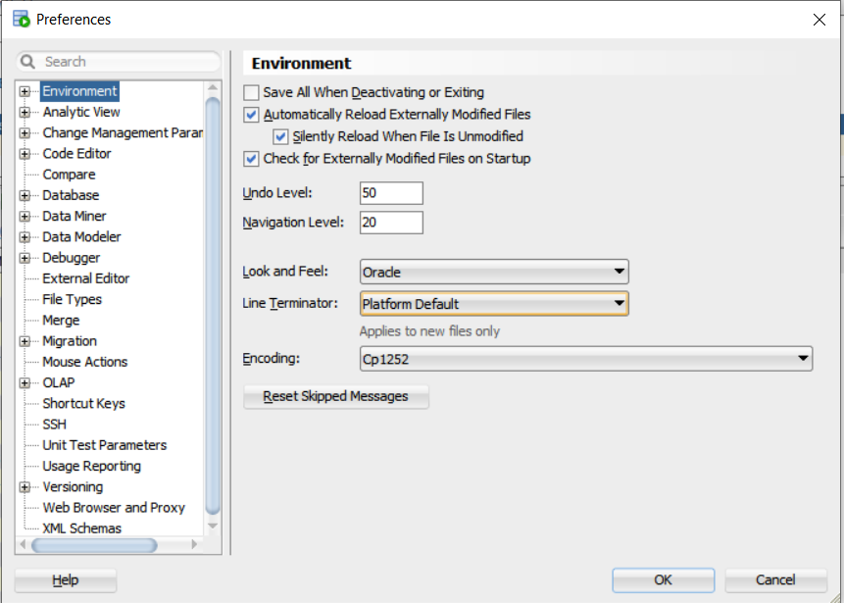

Practice 1-5: Anonymous Block Code.

1.a It doesn’t execute successfully.

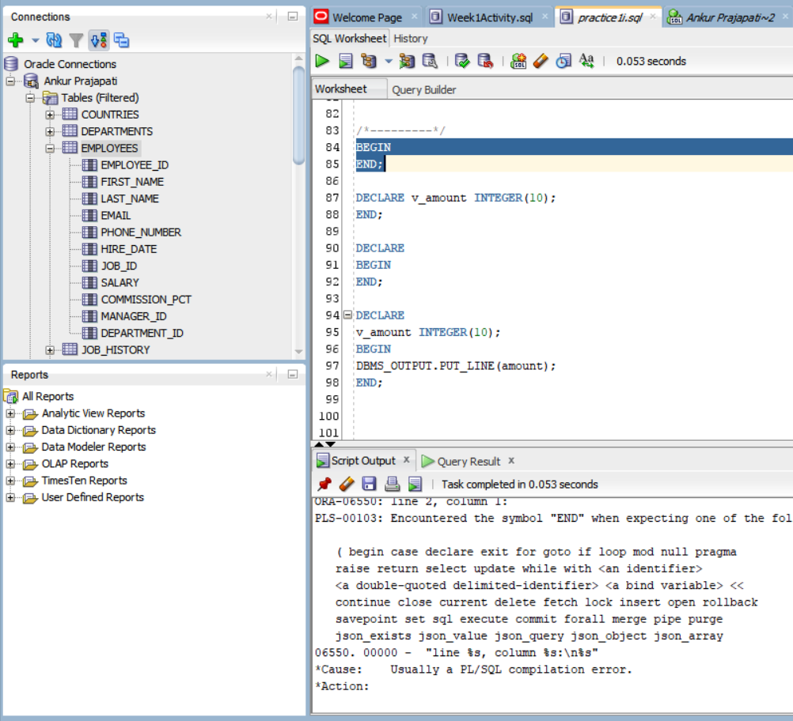

1.b It doesn’t execute successfully.

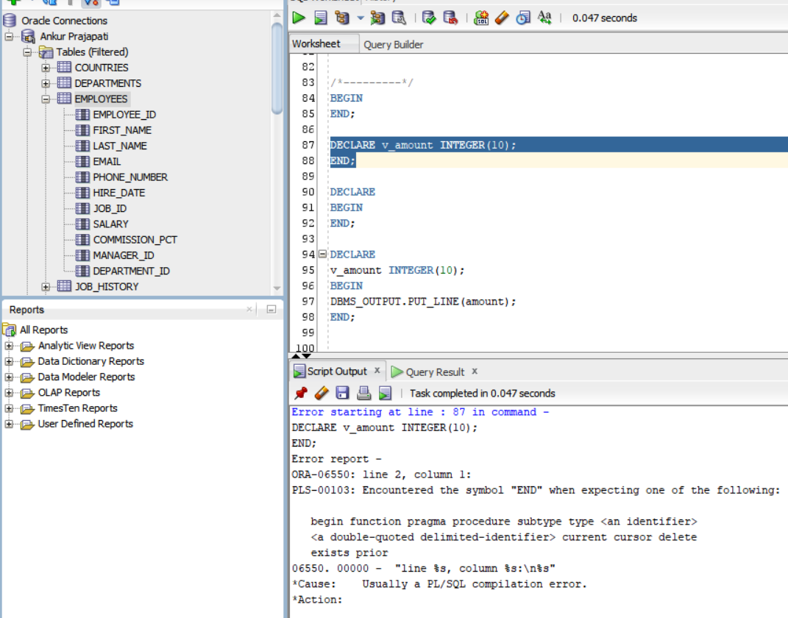

1.c It doesn’t execute successfully.

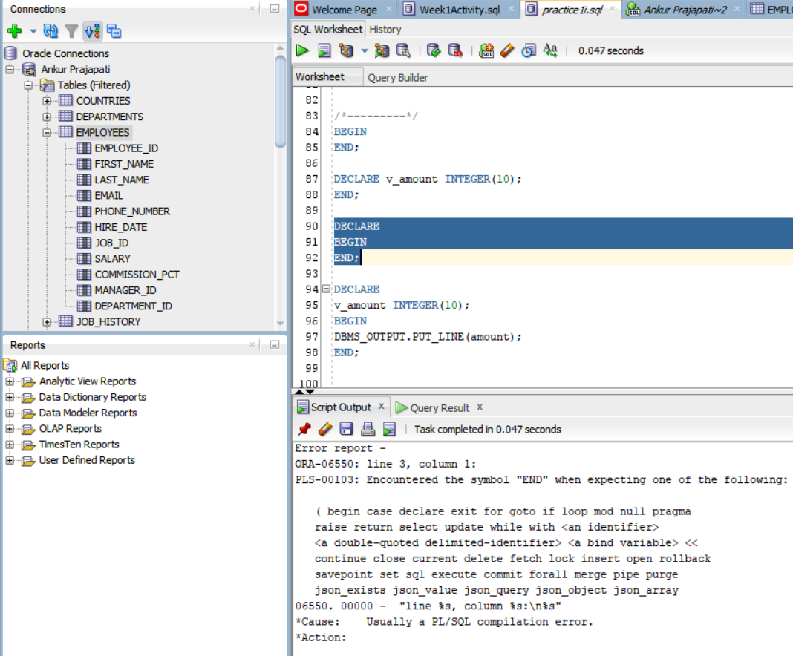

1.d It doesn’t execute successfully.

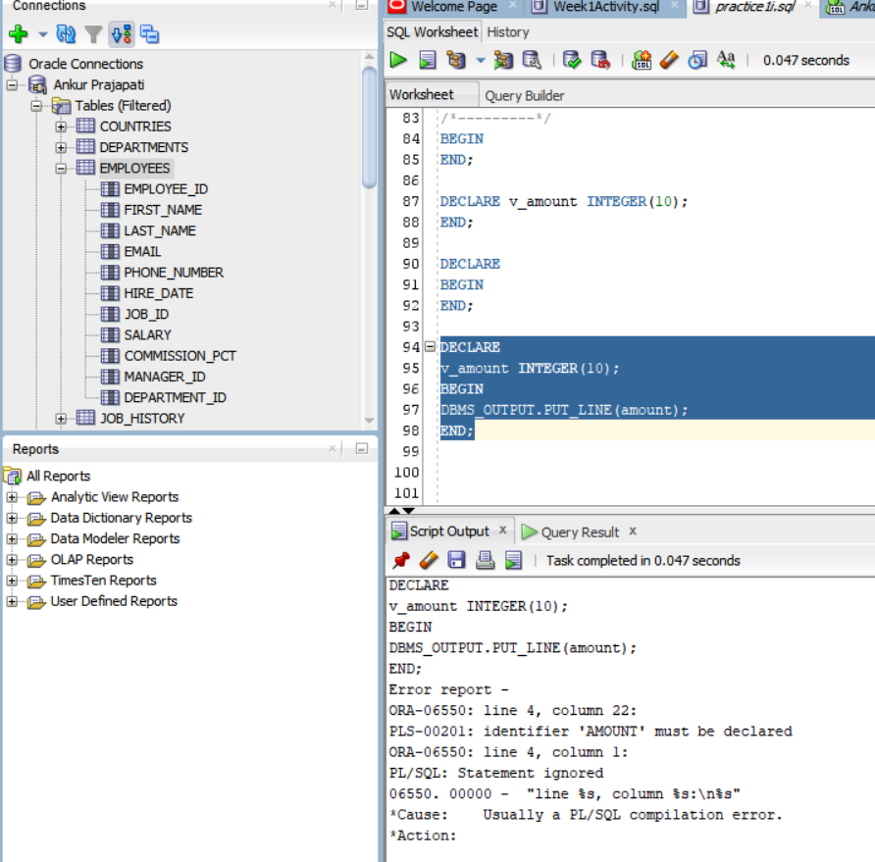

2. lab_01_02_soln

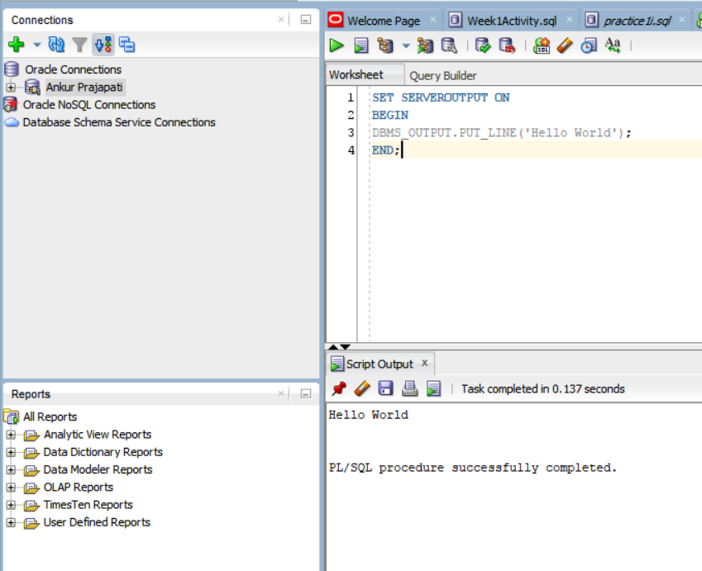

**Practice 2: Declaring PL/SQL Variables:**

1. Declaring PL/SQL Variables
   1. today 🡪 Valid
   2. last_name 🡪 Valid
   3. today’s_date 🡪 Invalid, because today’ gets ignored
   4. Number_of_days_in_February_this_year 🡪 Valid
   5. ISleap$year 🡪 Valid
   6. #number 🡪 not valid, because it starts with special character
   7. NUMBER# 🡪 Valid
   8. Number1to7 🡪 Valid
2. Identify valid and invalid variable declaration and initialization:
   1. number_of_copies PLS_INTEGER;

It’s an invalid declaration. Because, an arithmetic, numeric, string, conversion, or constraint error occurred when we try to use it.

* 1. PRINTER_NAME constant VARCHAR2(10)

Here we are declaring a constant and we haven’t initialized it here.

* 1. Deliver_to VARCHAR2(10) := Johnson;

It’s an invalid declaration because we have to use ‘Johnson’. Basically, it’s a malformed.

* 1. by_when DATE:= CURRENT_DATE+1;

It’s an invalid declaration because the input data did not contain a number where a number was required by the format model.

1. Examine the following anonymous block, and then select a statement from the following that is true.

True Statement:

a). The block executes successfully and prints fernandez.

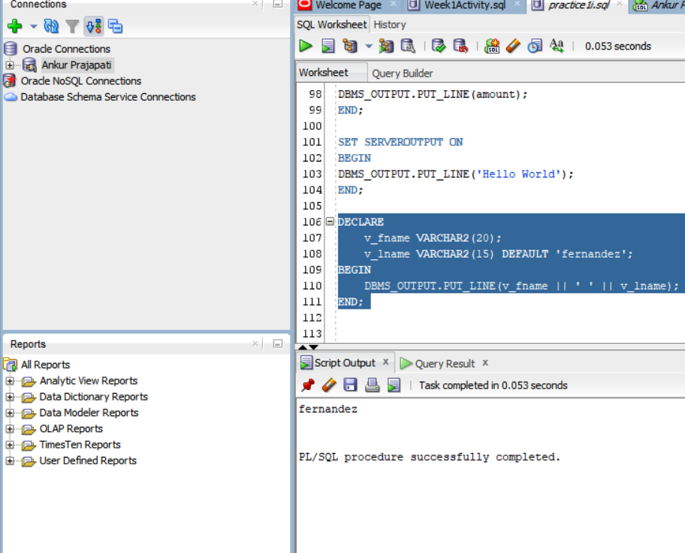

1. Modify an existing anonymous block

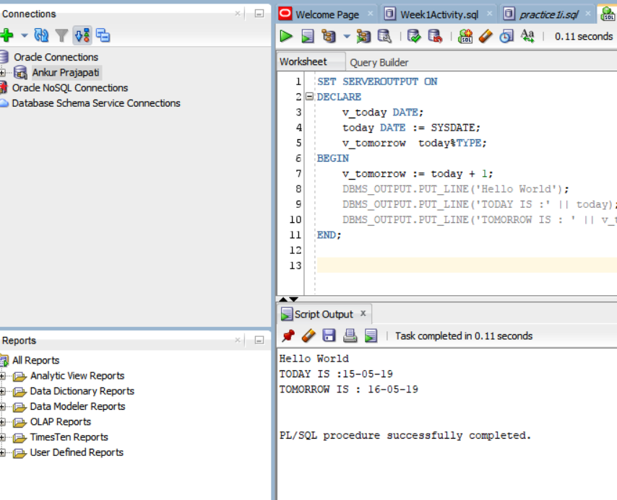

1. lab_02_05_soln

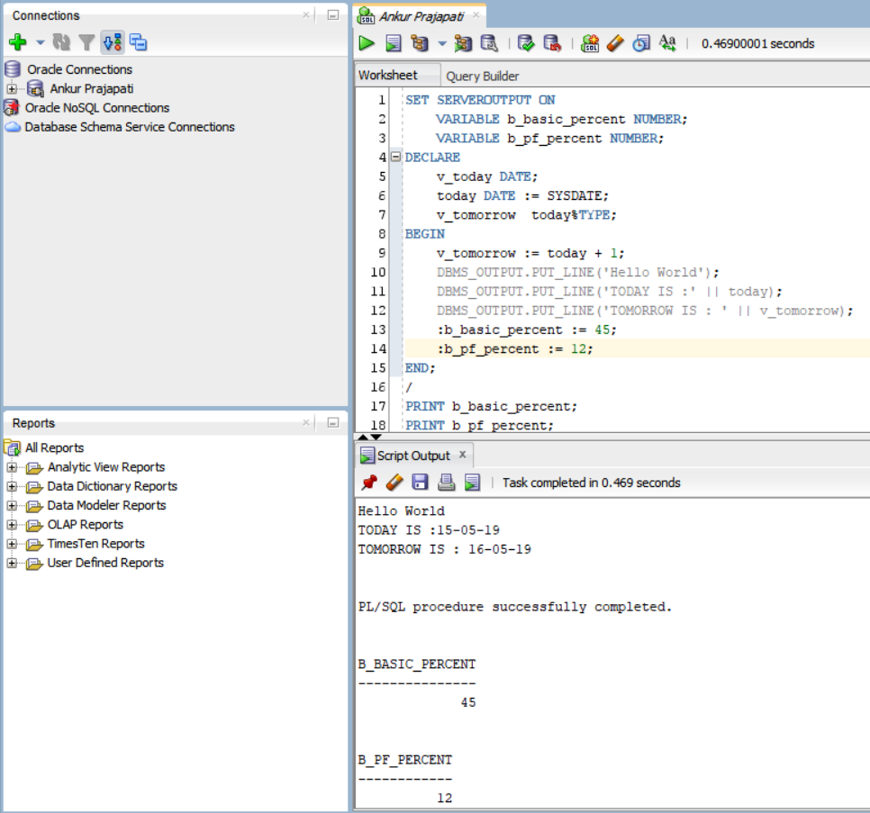

1. After Executing given block, it gives an output notifying that PL/SQL procedure successfully completed.

%TYPE attribute:

When we use %TYPE in every variable in declaration, the variable we declared will take a datatype of particular column associated with it. Basically, it used here to declare a variable according to a database column definition.

.

**Use of %TYPE in declaration of variables:** 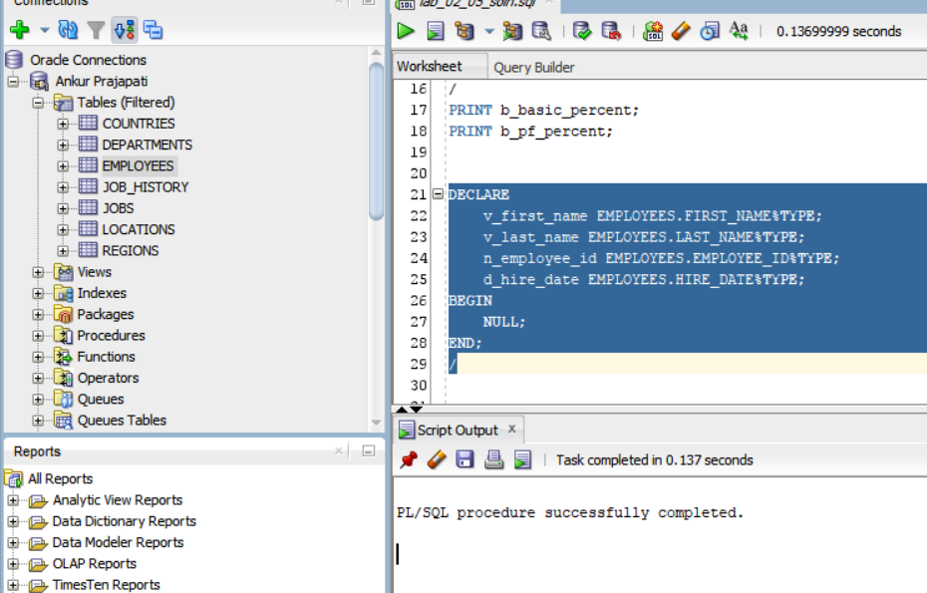

Assigning values to the variable:

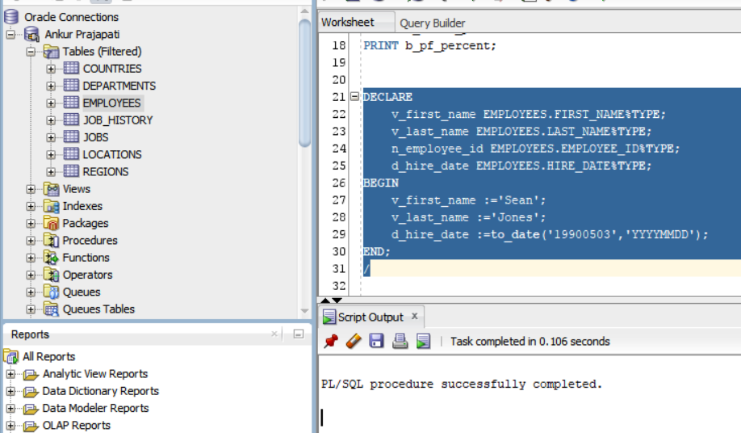

INTO and SELECT statement to assign a value to a variable.

